**Appendix**

Table of Contents

Data 1

Data sources 1

A1. Variable Table 1

Data cleaning 1

A2. Decision Tree 1

A3. Coding Ownership 1

A4. Full ownership categories 1

A5. Missing Data 1

Analyses 2

Descriptives 2

A6. Area Need Map 2

A7. Area Need Correlations 2

Additional Analyses 2

A8. Profit and Quality 2

A9. Ownership and Quality 2

A10. Full pooled regression model 2

A11. Investment as the reference category 2

Sensitivity Checks 2

Panel regression 2

A12. Specification curve 2

A13. Dynamic or within models 2

Multilevel model 2

A14. Accounting for ownership in profit regression 2

A15. Simple multilevel model 2

A16. Specification curve 3

A17. Simple regression 3

A18. Political control 3

A19. Binary quality 3

A20. Removing London 3

Falsification test 3

A21. Multinomial falsification 3

A22. Panel falsification 3

# Data

## Data sources

### A1. Variable Table

## Data cleaning

### A2. Decision Tree

### A3. Coding Ownership

### A4. Full ownership categories

### A5. Missing Data

# Analyses

## Descriptives

### A6. Area Need Map

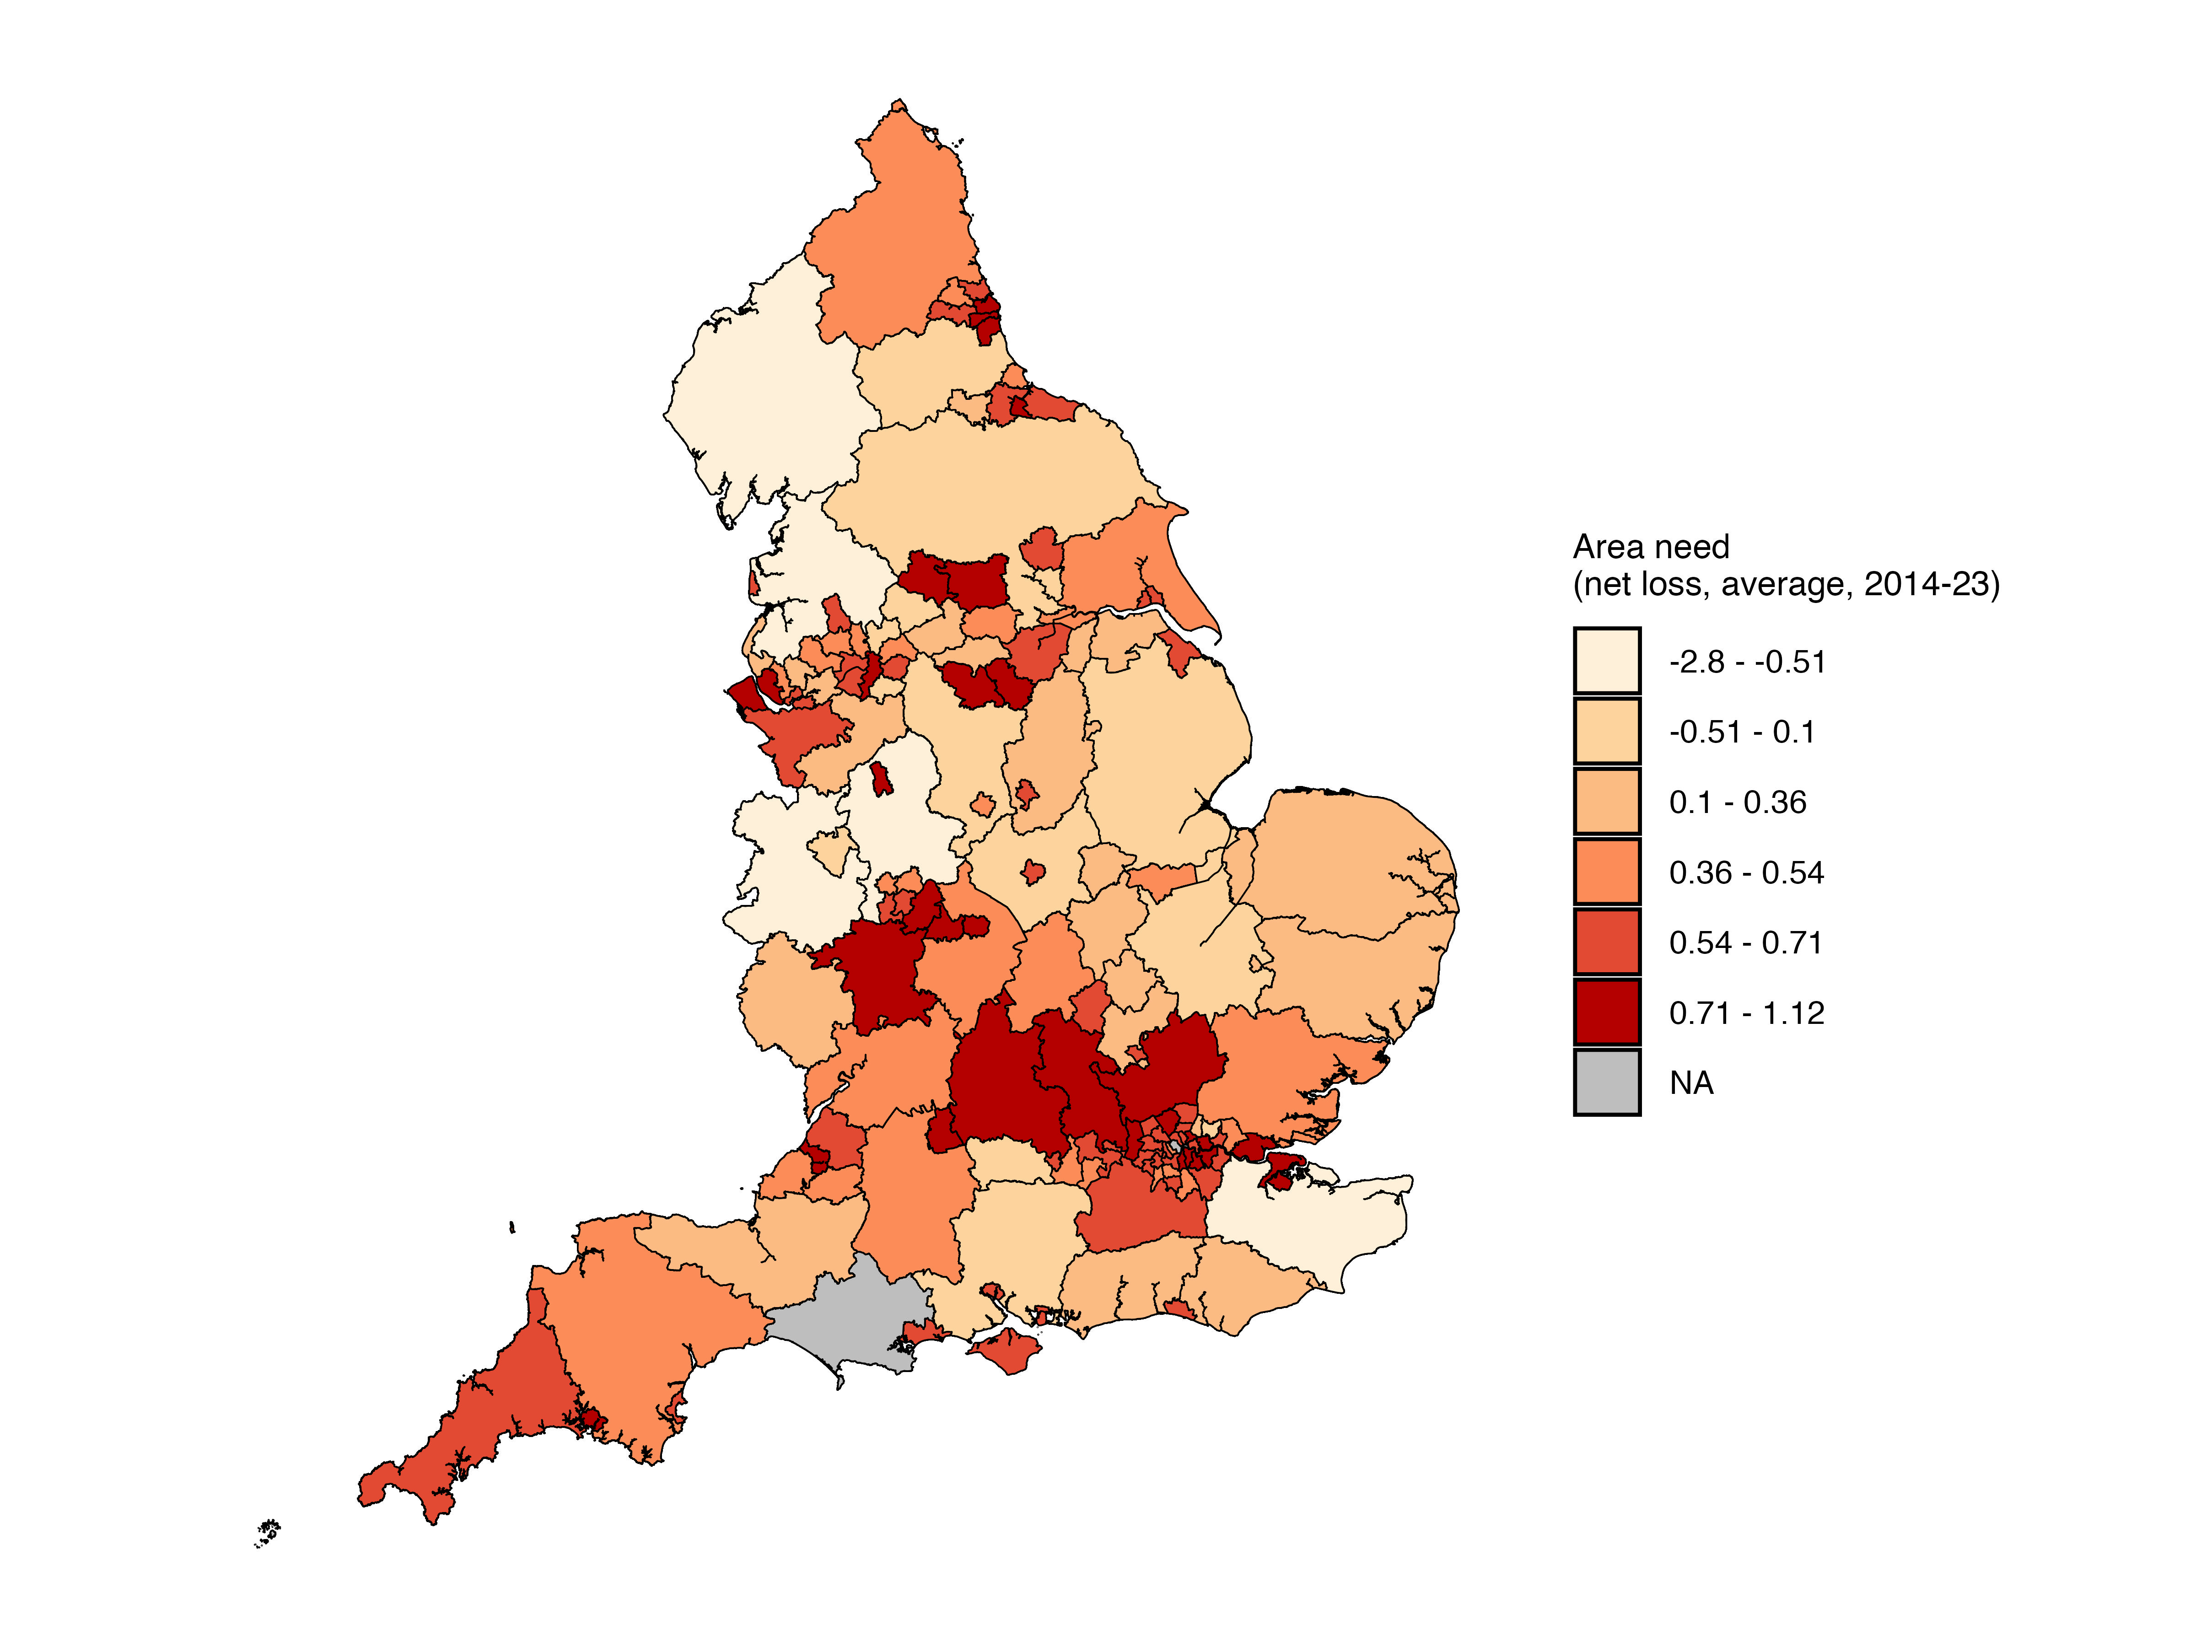

### A7. Area Need Correlations

## Additional Analyses

### A8. Panel regression

Figure 2. Relationship between Area need and changes to children home count.

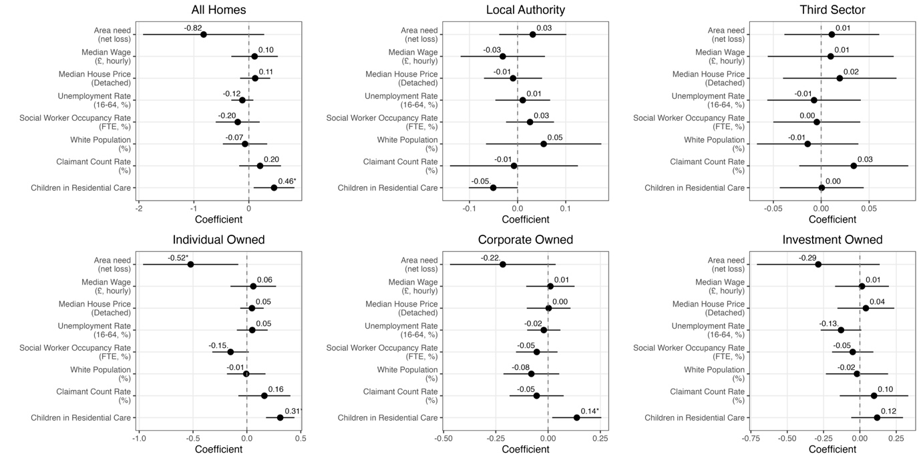  
*Caption: Figure presents coefficients from pooled panel regressions. Area need is a lagged by one year All independent variables are standardised. Robust, clustered standard errors with small sample transformaitons are used to calculate confidence intervals. Models include year and regional fixed effects.*

### A11. Investment as the reference category

### A12. Investment as the reference category

# Sensitivity Checks

## Multilevel model

### A14. Accounting for ownership in profit regression

### A15. Simple multilevel model

Convert the multinomial to binary and run it over

### A16. Specification curve

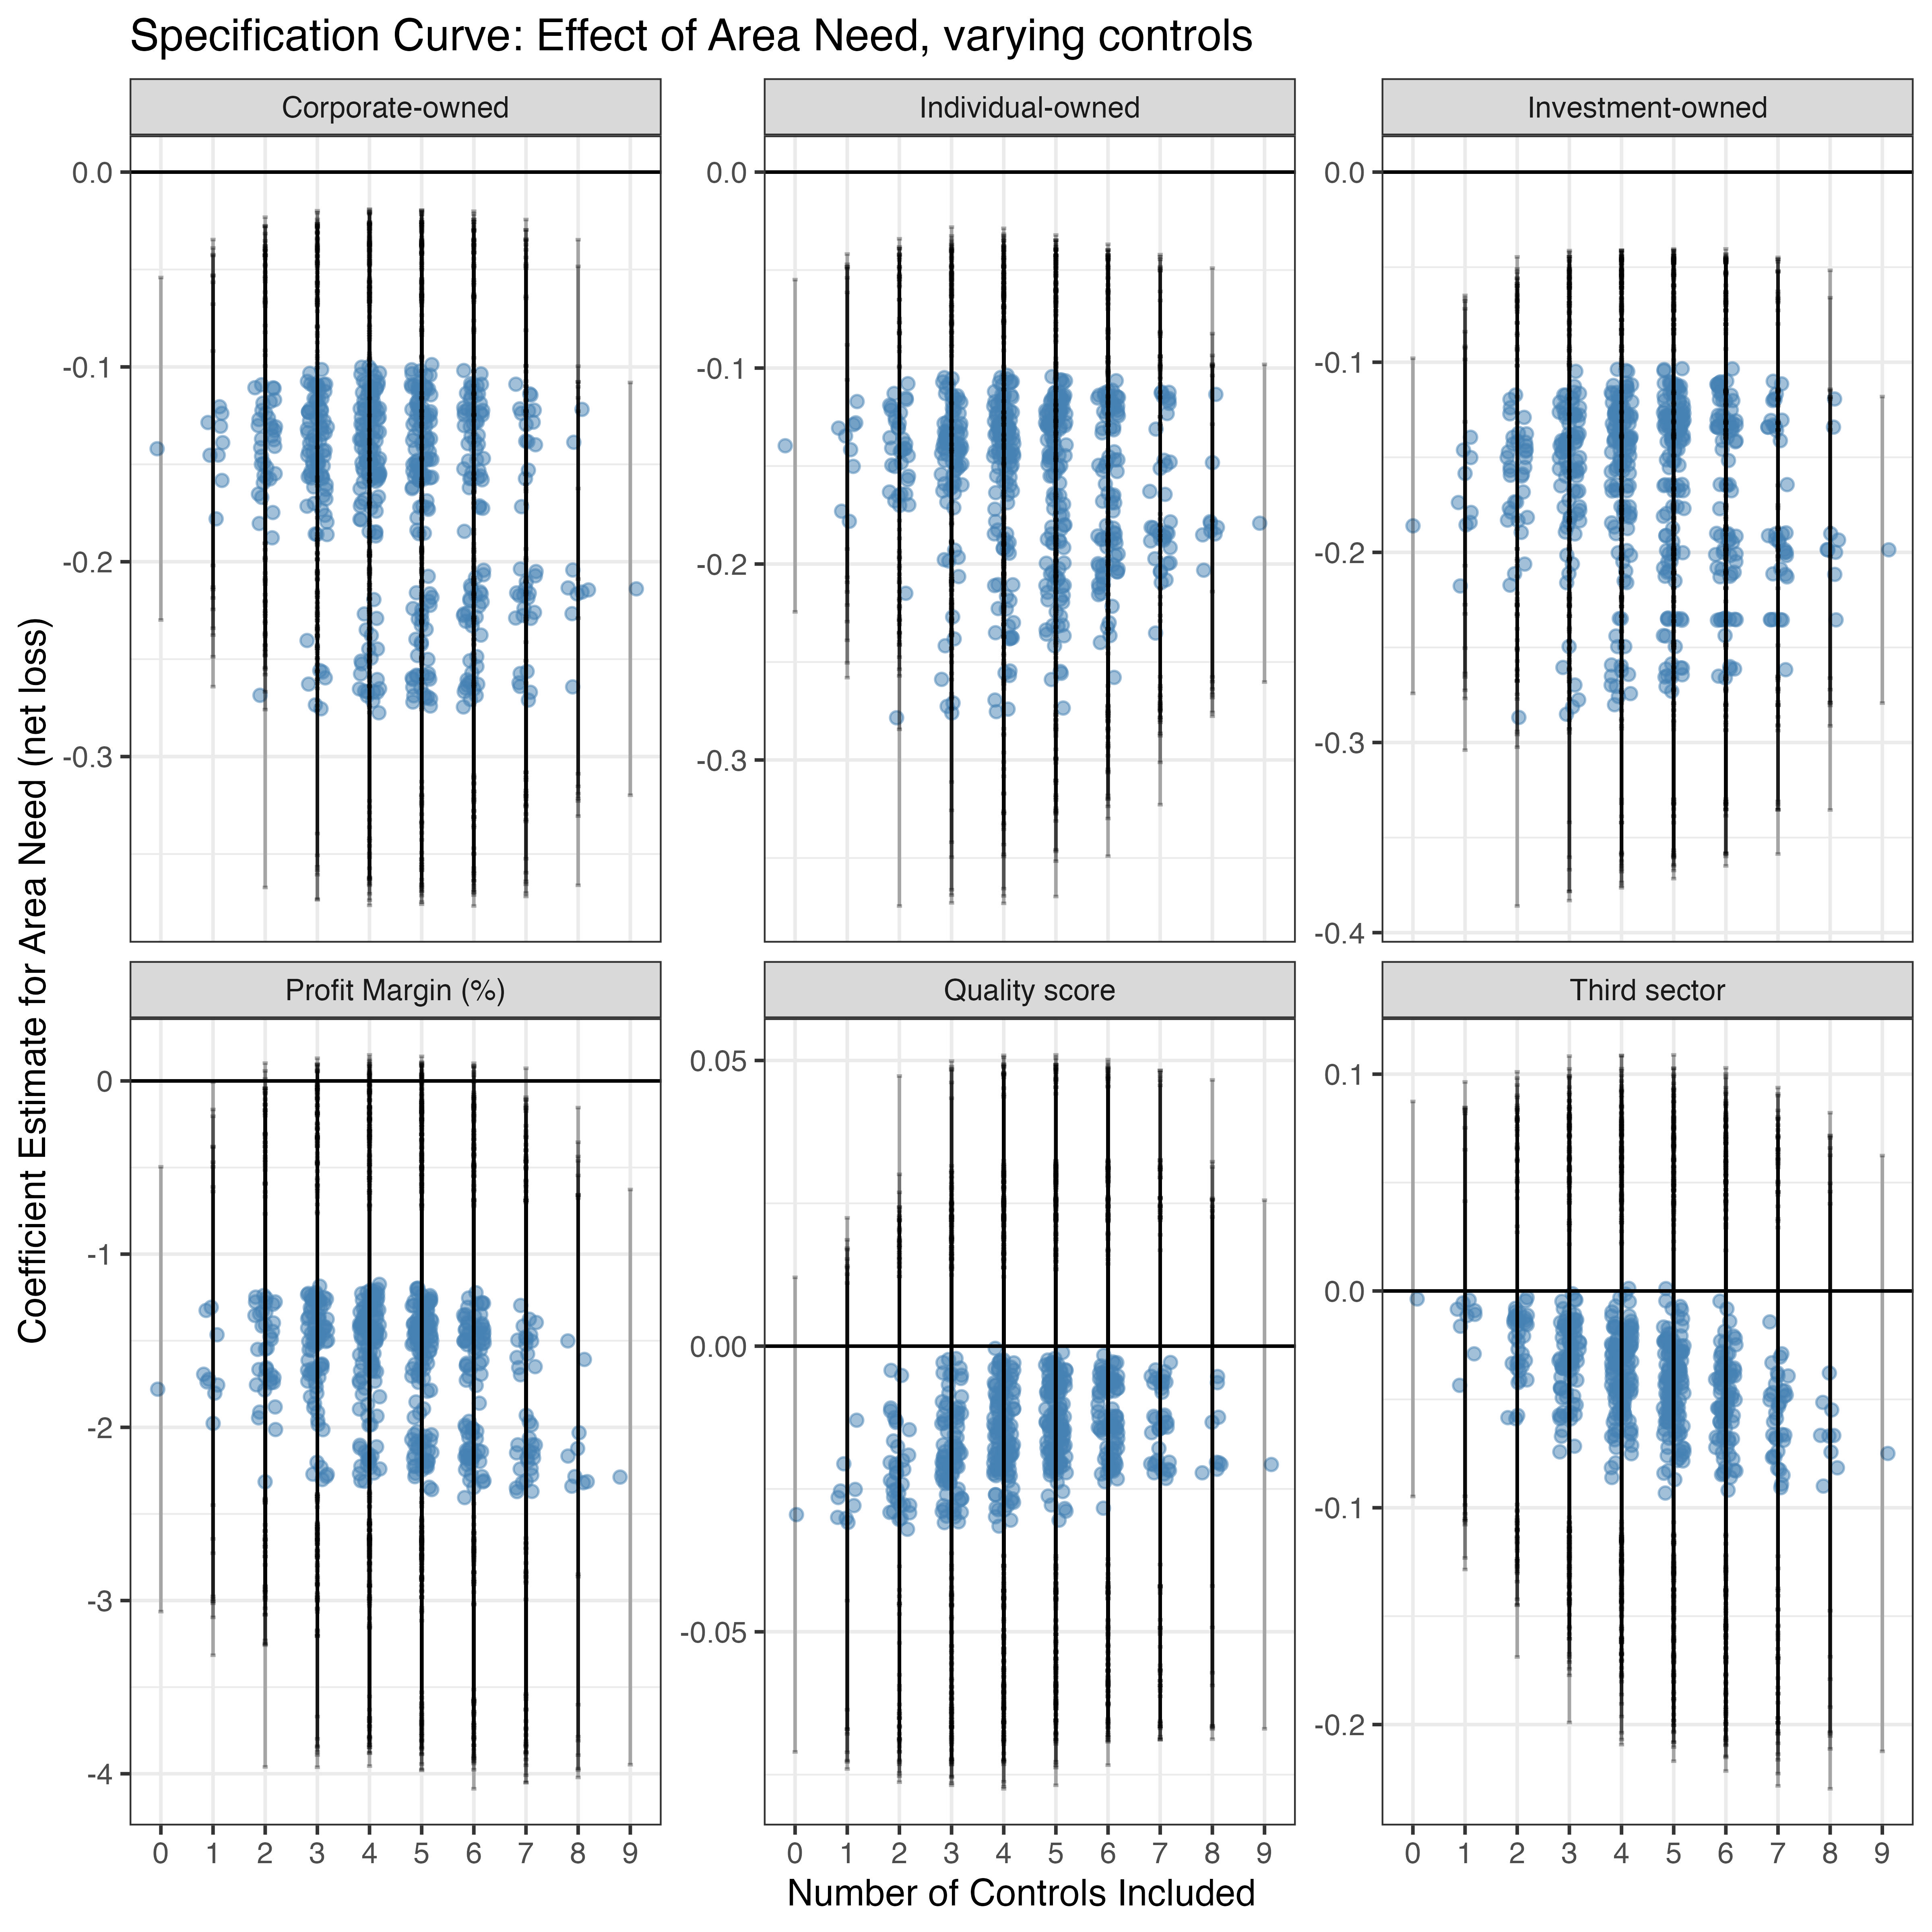

The variable that lowers corporate and investment is the number of children in care.

### A17. Simple regression

### A18. Political control

### A20. Removing London

## Falsification test

### A21. Multinomial falsification